**HOSTEL MANAGEMENT DATABASE**

**Project report**

**Submitted on fulfilment of project on**

**Hostel management database using DBMS[MySQL]**

**B Tech**

**Presidency University**

**Carried out at**

**Presidency University**

**Bengaluru**

**By**

**MANJUNATH ACHARI S (20191CSE0316)**

**Department of Computer Science & Engineering Bengaluru**



**CERTIFICATE**

This is to certify that the project entitled “HOSTEL MANAGEMENT DATABASE**”** has been successfully completed by MR. MANJUNATH ACHARI S of THIRD semester B Tech at **Presidency University, BANGALORE** as the Internet Of Things project in partial fulfilment for the award of B tech Degree course conducted by the Presidency University. The Project Report presented here is the bonafide work of the student.

**Guide: Head of the Department**

Prof Sunil Sahoo Thivakaran sir

ABSTRACT

‘Hostel management database’ provides a detailed view of how the students records, room allocation and courses. The hostel management system also equipped with some special features for helping hostel admin.Each record in the system has unique identity and it can be searched by an unique id. Use of this project in the hostel reduce the paper work in the hostel and also improves to the students of the hostel and admin.

Hostel management database is a desktop application for managing hostel records. *Hostel management database* helps hostel admin in managing records of the hostel in an efficient manner. These projects manage records of the students, hostel rooms and other things related to the hostel.

The manual way of hostel record management it is very difficult to find the record of all students their USN and about them and the information of about students who are accessing the internet with their ip address.

The main objective of developing Hostel management database is to save money and time. The proposed system generates following reports to help management of the hostel in decision making.

Use of this project in the hostel reduce the paper work in the hostel and also helps us to store the information about students in the hostel and rooms .

## ACKNOWLEDGEMENT

The success and the final outcome of this project required a lot of guidance and assistance from many people and we are extremely fortunate to have got this all along the completion of project work.

We sincerely extend our thanks to our project Guides **MR.SUNIL SAHOO** Assistant Professor in the Dept. of CSE for his guidance, technical expertise, encouragement, and timely help in making this project a reality.

Also, we would like to extend our sincere regards to all the non-teaching staff of the CSE Dept for their timely support.

### TABLE OF CONTENTS

**Sl. No. Chapter Page No.**

1. Introduction 1
2. Proposed System 1
3. Data Design 3
4. Entity relationship diagram 7
5. Implementation 8
6. Test-case Queries 13

**CONCLUSION** 14

**REFERENCES** 14

# INTRODUCTION

A hostel is an establishment which provides inexpensive food and lodging for a specific group of people, such as students, workers. **Hostels** are types of residences that provide tenants with common spaces to meet up. Thus, the **students** will live in a single or shared room, and will be able to take advantage of these common spaces to meet other **students** and carry out their daily activities. In hostel maintaining the students data such as their names and their room no and their Contact numbers. The main aim of this system is to develop that will conveying ever lasting solution to manual entries in hostel and make available a channel through which manager or hostel in charge can maintain the records easily by saving it digitally. They can be accessed whatever place they might find themselves.

**OBJECTIVE:-** It keeps track of all information about the students in the hostel, their contact numbers and total number of students staying in Hostel. The manager or hostel in charge will find it easy in this automated system rather than using the manual records. The system contains a database where all the information will be stored safely.

**2.PROPSED SYSTEM**

Hostel Room Allocation System is a database which aims at computerization of the current procedure of allocating hostel rooms. Currently, the process involves students filling up the forms and submitting them in respective hostel offices which involve a lot of paperwork, hence less efficient.

# 3.DATA DESIGN

3.1 Entities and Attributes

This section of the document explains the entities used in the project, their attributes and how they will work together. Basically, this is intended to make the design more easy and understandable for everyone.

**Entities**

* **Address**
* **Hostel**
* **Internet**
* **Student**
* **Student_in_out**
* **Student_tran**
* **Visitor**

**1.Address:- It is used to store the address of students.**

## Attributes

|  |  |  |
| --- | --- | --- |
| **Name** | **Data Type** | **Key** |
| **ADD_PIN** | **INTEGER** | **PRIMARY ATTRIBUTE** |
| **ADD_CITY** | **VARCHAR** | **NON_KEY ATTRIBUTE** |
| **ADD_STATE** | **VARCHAR** | **NON_KEY ATTRIBUTE** |
| **ADD_COUNTRY** | **VARCHAR** | **NON_KEY ATTRIBUTE** |

2. Hostel:- An Institution has many hostels and each hostel is represented using this ‘Hostel’ entity. Hostel model takes part in the following relationships.. Hostel has Students. Hostel has Rooms.

Tells how many hostels are there

## Attributes

**Name Data Type Key**

**H_NAME VARCHAR NON_KEY ATTRIBUTE**

**CAPACITY INTEGER NON_KEY ATTRIBUTE**

**HOSTEL_NO INTEGER PRIMARY ATTRIBUTE**

**F_SPORTS VARCHAR NON_KEY ATTRIBUTE**

F_NEWSPAP_NAME **VARCHAR** **NON_KEY ATTRIBUTE**

F_MESS_id **VARCHAR** **NON_KEY ATTRIBUTE**

VACANT_ROOMS INTEGER **NON_KEY ATTRIBUTE**

3. Internet:-This table is used to store the ip address who are accessing internet with their room no.

## Attributes

|  |  |  |
| --- | --- | --- |
| **Name** | **Data Type** | **Key** |
| HOSTEL_NO | **INTEGER** | **PRIMARY ATTRIBUTE** |
| ROOM_NO | **INTEGER** | **PRIMARY ATTRIBUTE** |
| IP_ADDRESS | **VARCHAR** | **NON_KEY ATTRIBUTE** |

4. Student:-This table is used for the student details like their name,rollno Email, date of birth, age, contact no.

## Attributes

|  |  |  |
| --- | --- | --- |
| **Name** | **Data Type** | **Key** |
| ROLL_NO | **VARCHAR** | **PRIMARY ATTRIBUTE** |
| FIRST_NAME | **VARCHAR** | **NON_KEY ATTRIBUTE** |
| LAST_NAME | **VARCHAR** | **NON_KEY ATTRIBUTE** |
| ROOM_NO | **INTEGER** | **NON_KEY ATTRIBUTE** |
| MAIL_ID | **VARCHAR** | **NON_KEY ATTRIBUTE** |
| DOB | DATE-TIME FIELD | **NON_KEY ATTRIBUTE** |
| AGE | **INTEGER** | **NON_KEY ATTRIBUTE** |
| CONTACT_NO | **BIG INTEGER** | **NON_KEY ATTRIBUTE** |
| ADD_HOUSE_NO | **INTEGER** | **NON_KEY ATTRIBUTE** |
| ADD_PIN | **INTEGER** | **FOREIGN ATTRIBUTE** |
| ADD_STREET | **VARCHAR** | **NON_KEY ATTRIBUTE** |

5.Student In out-This table gives information about student arrival and their leaving time and date.

## Attributes

|  |  |  |
| --- | --- | --- |
| **Name** | **Data Type** | **Key** |
| RECORD_NO | **INTEGER** | **PRIMARY ATTRIBUTE** |
| ROLL_NO | VARCHAR | **FOREIGN ATTRIBUTE** |
| STUDENT_ARR | TIMESTAMP FIELD | **NON_KEY ATTRIBUTE** |
| STUDENT_DEP | TIMESTAMP FIELD | **NON_KEY ATTRIBUTE** |

6. Student Tran -This table gives information about student attendance and which hostel they live in.

## Attributes

|  |  |  |
| --- | --- | --- |
| **Name** | **Data Type** | **Key** |
| ROLL_NO | VARCHAR | **PRIMARY ATTRIBUTE** |
| ATTENDANCE | VARCHAR | **NON_KEY ATTRIBUTE** |
| HOSTEL_NO | **INTEGER** | **FOREIGN ATTRIBUTE** |
| LIVING DAYS | **INTEGER** | **NON_KEY ATTRIBUTE** |

7. Visitor -This table gives information about visitor their contact no and also timings they visited.

## Attributes

|  |  |  |
| --- | --- | --- |
| **Name** | **Data Type** | **Key** |
| RECORD_NO | **INTEGER** | **PRIMARY ATTRIBUTE** |
| F_NAME | VARCHAR | **NON_KEY ATTRIBUTE** |
| L_NAME | VARCHAR | **NON_KEY ATTRIBUTE** |
| VISITOR_ARR | TIMESTAMP FIELD | **NON_KEY ATTRIBUTE** |
| VISITOR_DEP | TIMESTAMP FIELD | **NON_KEY ATTRIBUTE** |
| VISITOR_CONTACT | **BIG INTEGER** | **NON_KEY ATTRIBUTE** |
| HOSTEL_NO | **INTEGER** | **FOREIGN ATTRIBUTE** |

# 4.ENTITY RELATIONSHIP DIAGRAM

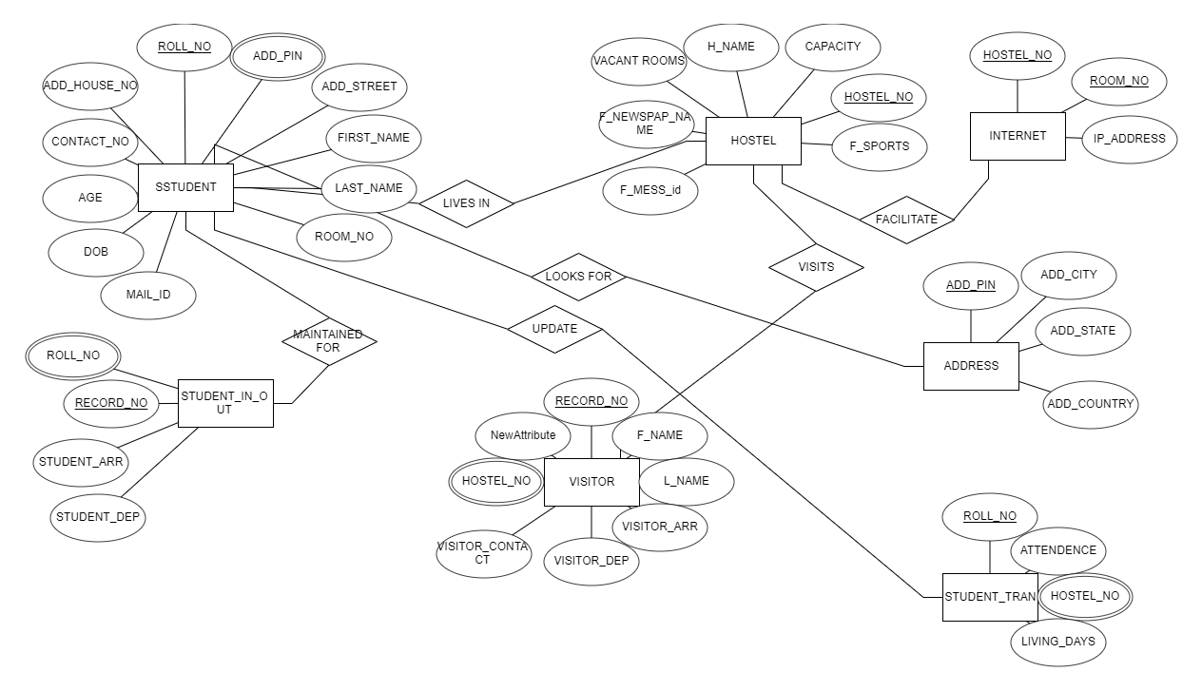

**5.IMPLEMENTATION**

Creating Address table:

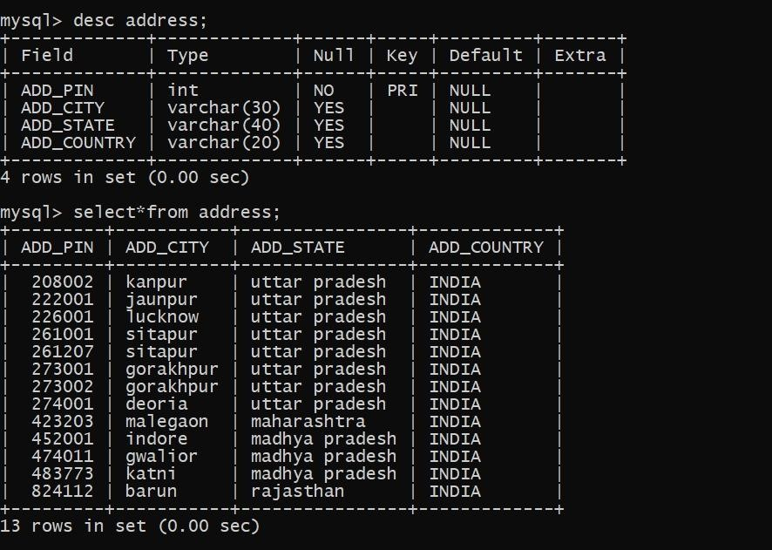

Creating student table:

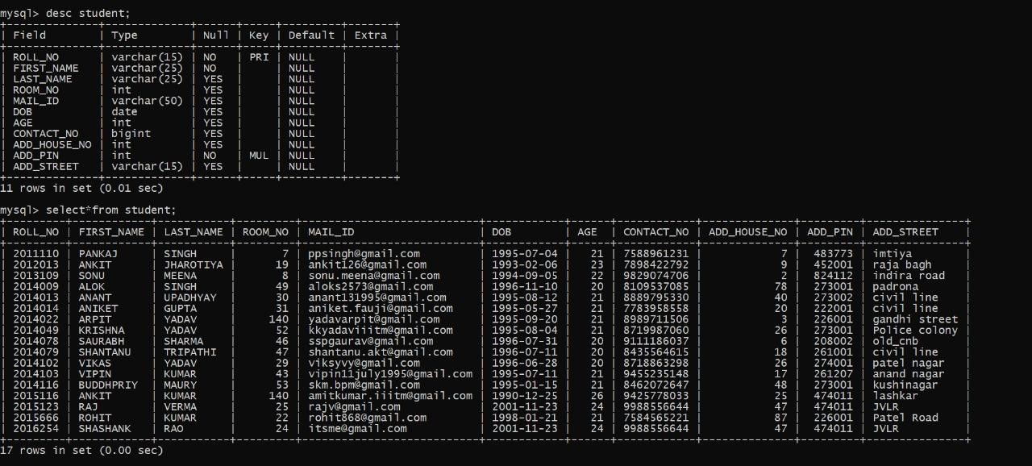

Creating table hostel:

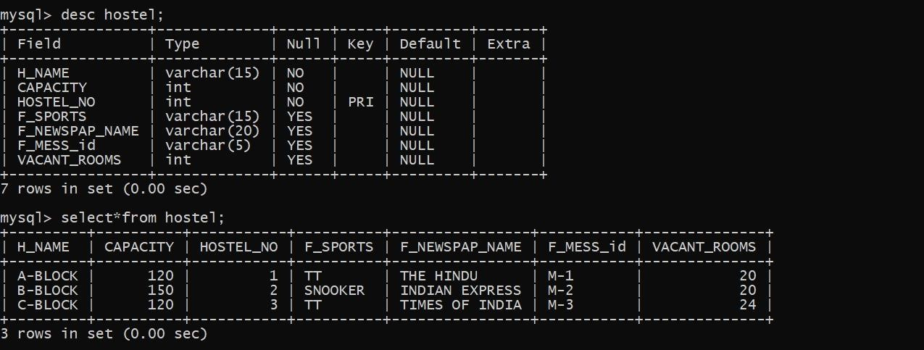

## Creating table Internet:-

Creating table Student:

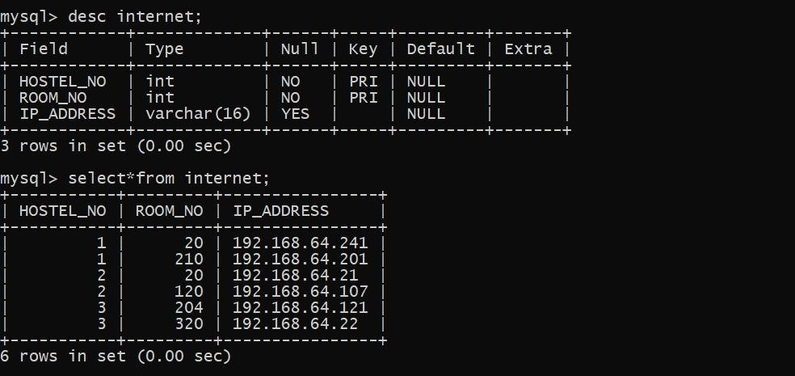

## Creating table Student_in_out:-

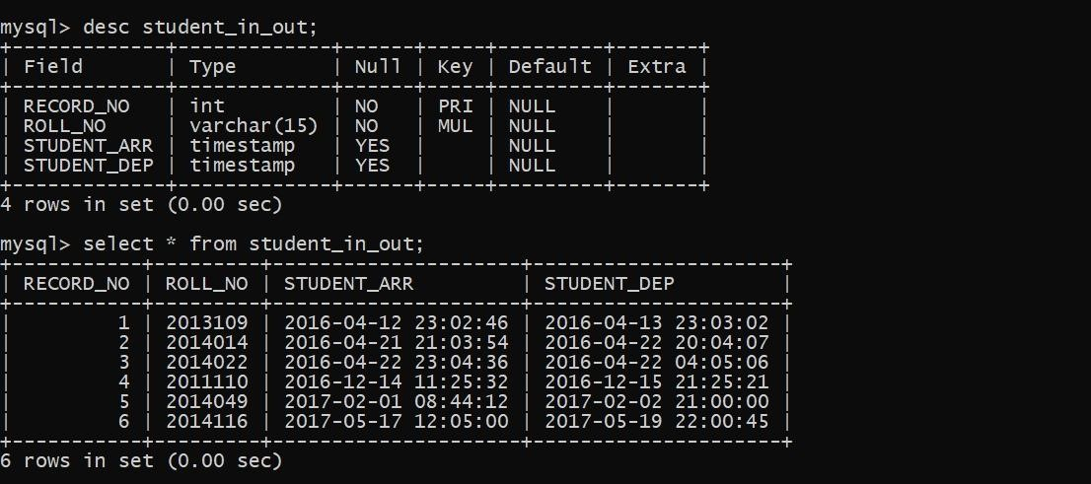

## Creating table Student_tran:-

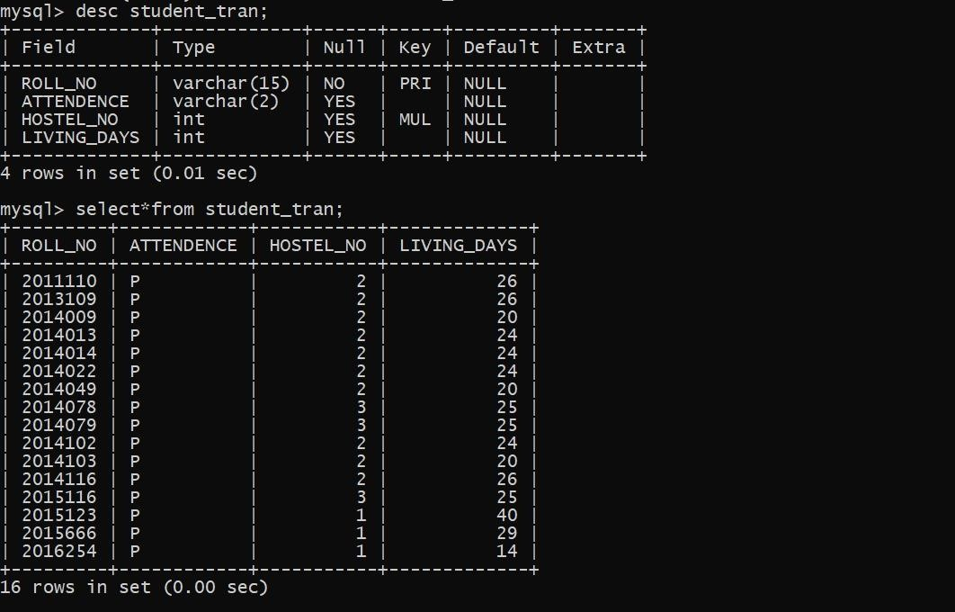

Creating table Visitor:-

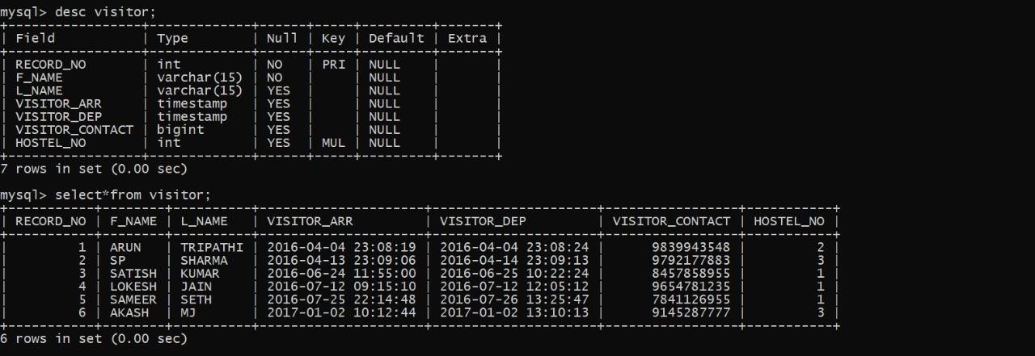

1. To see the no. of rooms vacant-

SELECT vacant_room FROM hostel WHERE HOSTEL_NO =1;

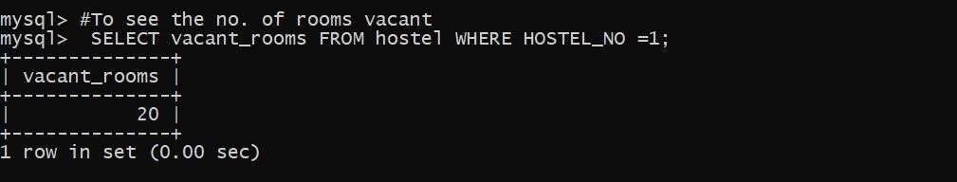

1. To get total info of hostel-

SELECT * FROM hostel WHERE hostel_no=1;

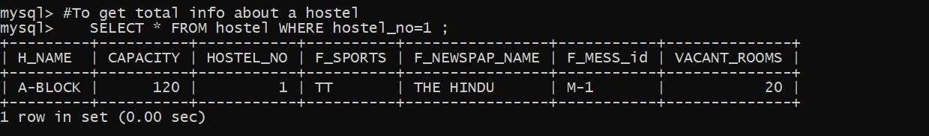

1. To get info of visitors to a particular hostel-

SELECT *FROM VISITOR WHERE hostel_no=2;

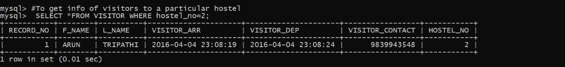

1. To get the arrival and departure time of a student from a hostel-

SELECT STUDENT_ARR,STUDENT_DEP,FROM

STUDENT_IN_OUT WHERE roll_no=’2013109’;

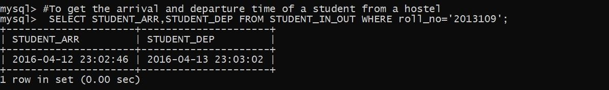

1. To check total capacity of a particular hostel-

SELECT CAPACITY,H_NAME FROM hostel WHERE hostel_no=2;

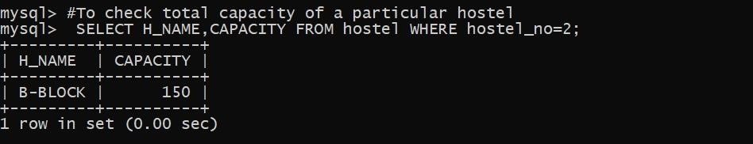

1. To select student info from room no-

SELECT * FROM student WHERE ROOM_NO=140;

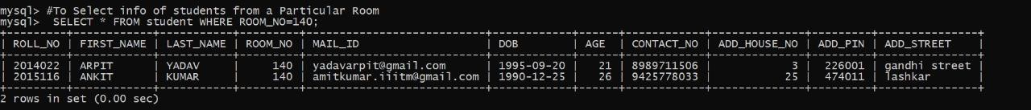

1. To check if a student is present in hostel or on leave on a particular-

SELECT ATTENDANCE,HOSTEL_NO FROMstudent_TRAN

WHERE roll_no='2014102';

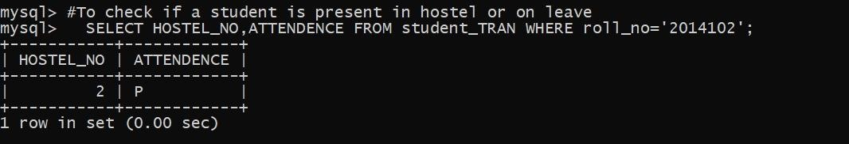

1. To check the newspaper supply in hostels:-

SELECT HOSTEL_NO,F_NEWSPAP_NAME FROM

HOSTEL Group by HOSTEL_NO;

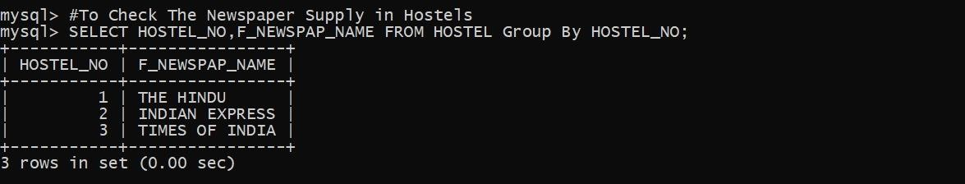

1. To select the list of students born in 1995:-

SELECT FIRST_NAME FROM student where DOB like

‘1995 ‘;

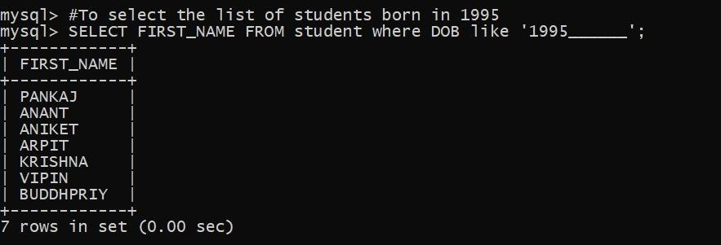

10.To display the Total no.of.days students spent in the hostel all together:-

SELECT sum(LIVING_DAYS) FROM student_tran;

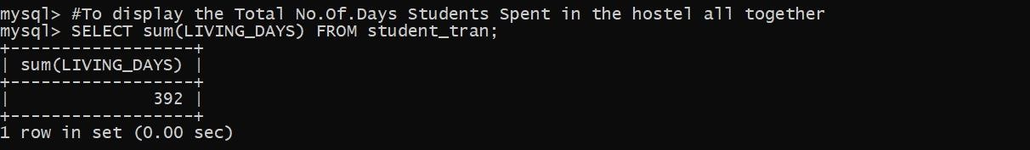

11.To display the no.of.visitors of a hostel:-

SELECT count(RECORD_NO) as NO_OF_VISITORS from visitors where HOSTEL_NO =3;

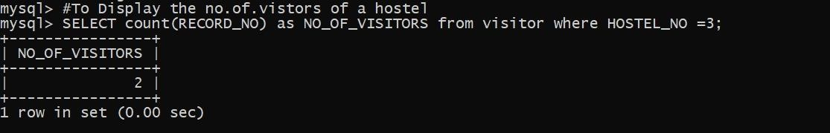

# 

**CONCLUSION**

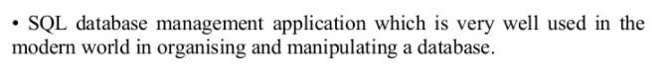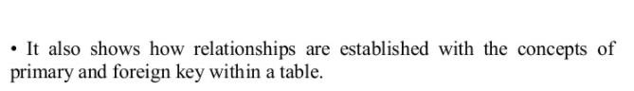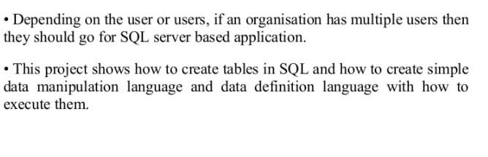

## REFERCENSES

• <https://erdplus.com/standalone>